ASSESSOR'S CHECK LIST FOR 2nd ASSESSOR MEETING (ME40321)

The second assessor meeting should be completed by Friday 3th April 2020 via remote means. The aim is to update the assessor on progress and brief the assessor on work completed.

The student should fill this form and email it to the assessor before the meeting. The form will be completed by the assessor for each student by ticking the appropriate boxes in the table below and email it back to the student.

The student will upload the completed form onto Moodle.

Student:……………Hannah Rosen…….…………………………………………………..
Project Title:………Adjustabike 2.0……………………………………………………….
Supervisor:…………Jérémy Bonvoison……………………………………………………
Assessor:……………Sally Clift……………………………………………………………
 | Excellent | Very good | Good | Satisfactory | Poor
Has the student fulfilled the majority of the aims and objectives?

Are the results achieved so far credible and in line with expectations?

Is the work completed of the required standard?

Does the plan for any remaining work seem realistic and achievable?

Has the student kept a well-documented log book?

Has the student started writing the final report?
Has the student been able to discuss their report structure? Does the structure seem reasonable?

Please make general comments in the space below:

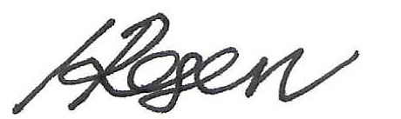

Assessor's signature or Initials: ……………… Student's signature or Initials: ………………
Date of meeting: …Tuesday 31st March…….

